**Installing Angular and Running the Site**

* Please install nodejs (12.13.0 LTS) through <https://nodejs.org/en/> website.

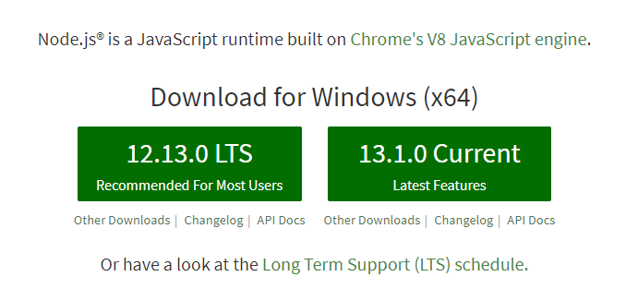

* Please install Angular CLI globally through the following command in the command line:

npm install –g @angular/cli@8.3.29

* Please install Angular CLI locally through the following command:

npm install --save-dev @angular/cli@8.3.29

* Then, please run the following commands:

npm install @angular-devkit/build-angular@0.803.26

npm install

* Once completed, in order to run the project, please run IIS Express in Chrome
* Please see screenshots below for how application works

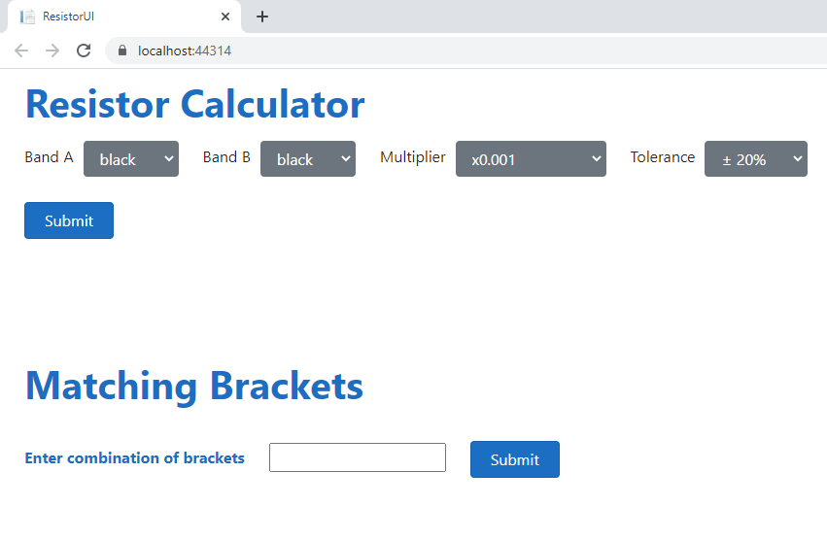

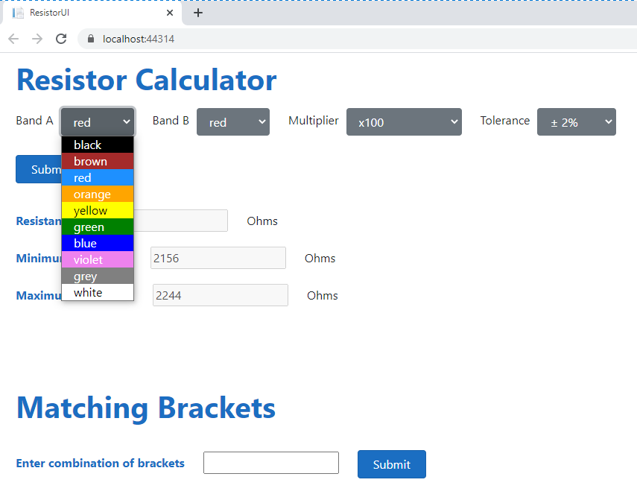

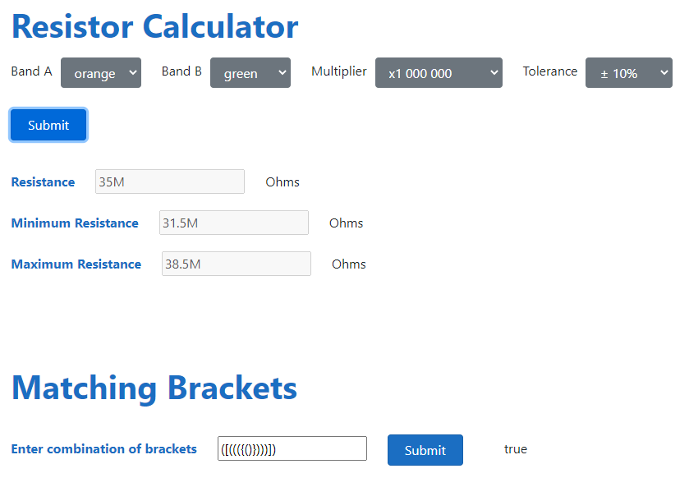

**Solution 1**

In the Visual Studio Project.

**Solution 2**

NUnit Tests

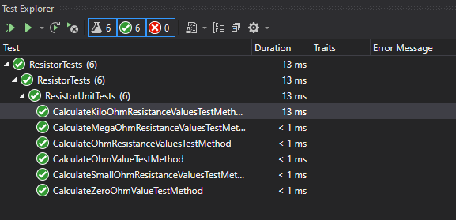

**Solution 3**

public SubItemSummary[] GetSubItemSummaryTest(string itemNumber)

{

List<SubItemSummary> subItemSummary = new List<SubItemSummary>();

GetSubItems(itemNumber).ToList().ForEach(item => subItemSummary.AddRange(TransformSubItems(item, item.GetSubItems())));

return subItemSummary.ToArray();

}

**Solution 4**

Included in UI.

areBracketsClosed(bracket: string): boolean

**Solution 5**

Created Angular UI for Resistor.